**NJOY, a Once Bankrupt E-Cigarette Maker, Now Seeks $5 Billion Valuation**

Company rolls out new device and seeks out big tobacco companies looking to take a run at Juul

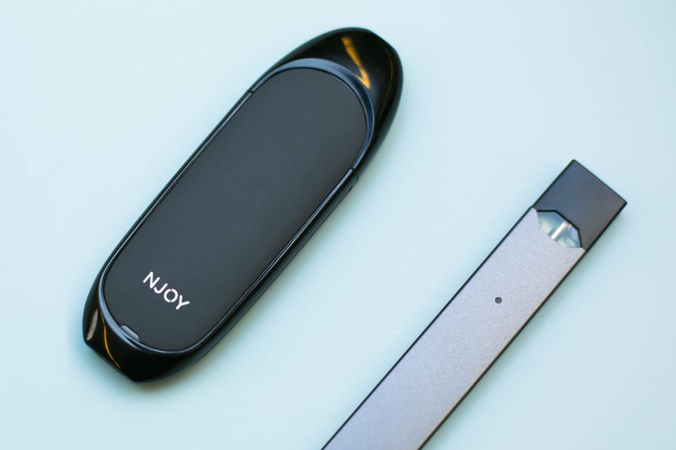

NJOY and Juul e-cigarettes. NJOY is pursuing a new funding round that could value it at as much as $5 billion.

PHOTO: ANGELA OWENS/THE WALL STREET JOURNAL

*By*

Jennifer Maloney *and* Juliet Chung

Updated May 1, 2019 2:56 pm ET

E-cigarette maker NJOY Holdings Inc. is pursuing a funding round that would value the company at as much as $5 billion, and it is trying to interest big tobacco companies looking to take a run at market leader Juul Labs, according to people familiar with the matter.

The discussions mark a turnaround for NJOY, an e-cigarette pioneer that [filed for bankruptcy protection](https://www.wsj.com/articles/e-cigarette-producer-njoy-files-for-bankruptcy-seeks-buyer-1474312328?mod=article_inline) three years ago saddled with debts and plunging sales when a new product failed to catch on.

# NJOY, E-Cigarette Maker, Receives Funding Valuing It at $1 Billion

***BY ALEXANDRA STEVENSON -***  FEBRUARY 28, 2014 4:31 PM *February 28, 2014 4:31 pm 5*

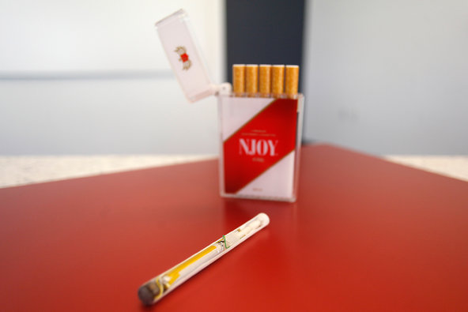

Investors in NJOY include Sean Parker, the co-founder of the now-defunct Napster, and Peter Thiel, the founder of PayPal.Credit Joshua Lott for The New York Times

Even as electronic cigarettes draw the scrutiny of regulators around the world, investors are seeing potential in the fledgling industry.

This week, the electronic cigarette maker NJOY received a $70 million capital injection from a group of investors including Brookside Capital and [Morgan Stanley](https://dealbook.on.nytimes.com/public/overview?symbol=MS&inline=nyt-org) Investment Management, in the latest vote of confidence for a fast-growing industry.

The company, based in Scottsdale, Ariz., boasts several entrepreneurial investors including Sean Parker, the co-founder of the now-defunct Napster, and Peter Thiel, one of the founders of PayPal.

The private round of funding values the company at around $1 billion, according to a person briefed on the financials, and comes as regulators in Europe and the United States are looking to legally define parameters for the industry. Earlier this week, the [European Parliament](https://topics.nytimes.com/top/reference/timestopics/organizations/e/european_parliament/index.html?inline=nyt-org) approved regulations in the [European Union](https://topics.nytimes.com/top/reference/timestopics/organizations/e/european_union/index.html?inline=nyt-org) for the industry that could be copied in other countries.

#### Related Links

* [European Parliament Approves Tough Rules on Electronic Cigarettes (Feb. 26, 2014)](https://www.nytimes.com/2014/02/27/business/european-union-approves-tough-rules-on-electronic-cigarettes.html?hpw&rref=business)

Electronic cigarettes, or e-cigs for shorthand, are being marketed as an alternative to real cigarettes. They simulate tobacco cigarettes, but operate as battery-powered devices that deliver nicotine and/or flavoring through a liquid solution. Atomizers create the same sensation a smoker gets from blowing smoke.

But the industry has come under scrutiny from some health officials who say the safety of e-cig products has not yet been proved. Others raise concerns that a boom of e-cigs products will revitalize the appeal of cigarettes.

NJOY, whose e-cig products are sold in more than 90,000 stores in the United States, and more than 40,000 outlets across Europe, has marketed itself as a technology company that is trying to defeat a health epidemic rather than prolong its demise.

“We believe that only an independent company can have as its corporate mission the extraordinary technological and important objective to make cigarettes obsolete,” said Craig Weiss, chief executive of NJOY. Mr. Weiss, who is a patent lawyer and former hedge fund manager, compared the initiative and its ambition to putting a man on the moon.

His brother Mark, also a lawyer, founded NJOY in 2006 after a trip to China inspired him to enter the electronic cigarette market. During his trip, he visited a trade show where e-cigs, so large they looked like cigars, were being showcased.

“It seemed to him that this was the future of smoking,” said Mr. Weiss, who took over as president of NJOY in 2010.

It is a view not shared by the Europe, [which ruled this week](https://www.nytimes.com/2014/02/27/business/european-union-approves-tough-rules-on-electronic-cigarettes.html?hpw&rref=business) that advertising for e-cigarettes would be banned in 28 nations. The new rules, which will be enforced in 2016, also set limitations for the amount of nicotine e-cigarettes can contain and will force e-cigarette makers to include health warnings on the product.

In the United States, the [Food and Drug Administration](https://topics.nytimes.com/top/reference/timestopics/organizations/f/food_and_drug_administration/index.html?inline=nyt-org) has categorized e-cigarettes as “tobacco products” but has not yet determined any rules for them. But pressure has been building from lawmakers to take a harder line and begin immediate regulatory oversight.

For now, sales of e-cigarettes continue to soar. Industry experts estimate that the market is worth nearly $2 billion. although that is just a fraction of the $80 billion-a-year tobacco industry in the United States. Analysts at [Wells Fargo](https://dealbook.on.nytimes.com/public/overview?symbol=WFC&inline=nyt-org) recently estimated that e-cigarettes could replace regular cigarettes within the next decade.

But as e-cigarettes become more popular, major tobacco companies are taking note. Lorillard, the maker of cigarette brands like Newport and Kent, acquired Blu eCigs for $135 million in 2012, and RJ Reynolds, Japan Tobacco International and British American Tobacco have also scooped up stakes in emerging e-cigarette companies.

The presence of such big tobacco firms has caused some critics to question whether e-cigarettes are just a new way to get people hooked on nicotine, an addiction that could lead them to turn to tobacco cigarettes.

To counter that impression, NJOY points to its unusual team of executives that include veterans of the old tobacco industry, as well as scientists and well-respected doctors to help with this image. It recently added former Surgeon General Dr. [Richard H. Carmona](https://www.nytimes.com/top/reference/timestopics/people/c/richard_h_carmona/index.html?inline=nyt-per), who served in the [George W. Bush administration](https://topics.nytimes.com/top/reference/timestopics/people/b/george_w_bush/index.html?inline=nyt-per), to its board.

With lighter regulation in the United States, many American e-cigarette companies have taken advantage, introducing a flurry of advertising campaigns on television. In 2012, NJOY ran a series of ads in print, television and online with the tagline: “Cigarettes, you’ve met your match.”

The industry has already made strides in popular culture. In the current season of the popular [Netflix](https://dealbook.on.nytimes.com/public/overview?symbol=NFLX&inline=nyt-org) political series “House of Cards,” the main character, Frank Underwood, is caught by his wife smoking a cigarette. She accuses him of caving in to his addiction.

“No, I’m not,” he tells her, indicating it’s an e-cigarette. He adds, “Addiction without the consequences.”

## Founded Year

2006

## Stage

Unattributed - VI | Alive

## Total Raised

$578.14M

## Last Raised

$4.99M | 1 yr ago (Before  2021)

## About NJOY

NJOY develops electronic cigarettes. The company offers a variety of rechargeable and non-rechargeable electronic cigarette products made for adult smokers. These products provide nicotine and rich tobacco and menthol flavor without smoke or odor, and cost less than traditional cigarettes to use.

## 

## NJOY Headquarter Location

155 6th Avenue 2nd Floor

New York, New York, 10013,

United States

833-275-6569